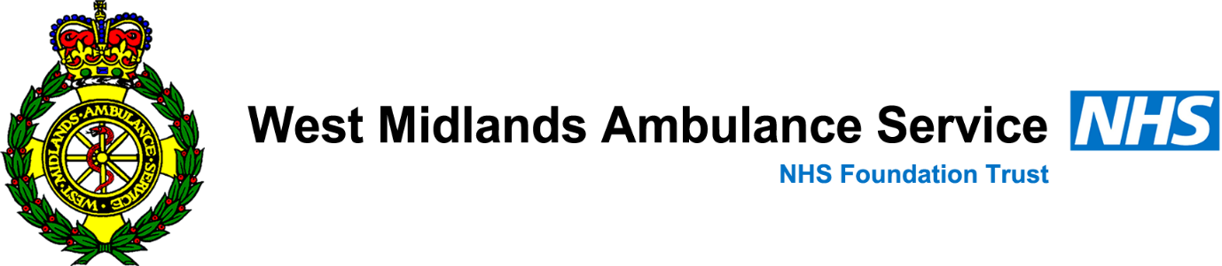
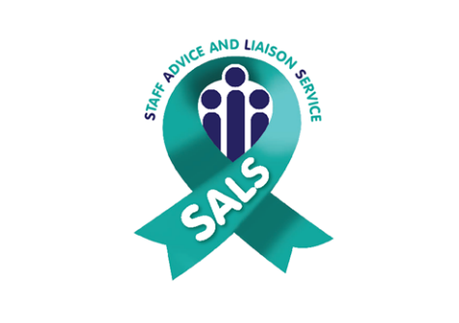
SALS RESPONSE TO EMERGENCY PROTOCOL
INVOLVING STAFF
SALS 24/7 Line Number - 01384 215880

The SALS Line will notify the On-call Coordinator who will arrange appropriate resource and deal with SALS Advisor welfare.
In the event of a sudden unexpected death or expected death after illness of a member of WMAS Staff please contact the SALS Helpline.

SALS Advisors will attend the HUB / Work base and support Management in notifying staff in person or by phone of what has happened.

The SALS Advisors will remain at the HUB to support staff for as long as needed but usually for 24-48 hours after the event. This is flexible depending on the situation and what staff need to feel supported.

