SALS FOR LEADERS
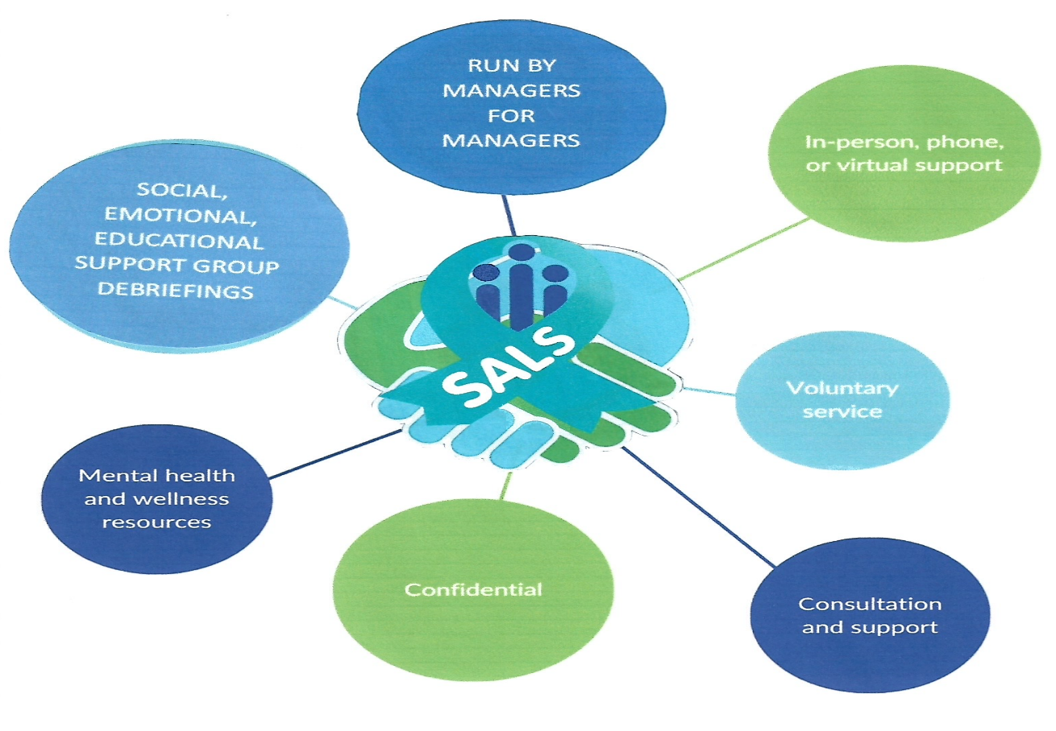
Support for Managers
We recognise that it can sometimes be challenging for managers in a large organisation to ask for help—particularly when peer-support services are delivered by colleagues from their own teams or areas.
Being a manager does not make you immune to the pressures of work or everyday life. Everyone needs support at times.
To ensure managers have a confidential and comfortable route to seek help, we have established SALS for Leaders—a dedicated peer-support group within SALS, delivered by managers who are SALS-trained and understand the unique demands of leadership roles within the Trust.
This confidential service is designed specifically for managers who may prefer not to approach the main SALS team.
Our Advisor Team
The SALS for Leaders group is made up of:
- SALS Coordinators
- SALS trained Operational Managers
These individuals are SALS-trained and experienced in supporting colleagues at leadership level.
How to Contact Us
You can reach the group directly via the dedicated email address below.
Emails are received only by the SALS Coordinators who will discuss with you which one of the available SALS for leaders team you would like to support you.
You may request support from the whole group or ask to work with one advisor.
Confidentiality
All information shared with SALS for Leaders is treated with the highest level of confidence.
You do not have to face difficulties alone—support is here when you need it.
Email: SALSFORLEADERS@WMAS.NHS.UK

